**Pract 3**

**Create and simulate simple adhoc network**

**1** Click on windows button and search for **omnetpp**

**2** open omnetpp and type **omnetpp (make sure you click)**

**3** expand the **inet** folder >> right click on **adhoc** and create new folder

4 name the new folder and right click on the new folder and select **NED**

5 create ned and Select **New Managed Mobility Wireless Network Wizard** and Click Next>>Next>>Finish

6 Run

**Pract 5**

**Create a basic MANET implementation simulation for packet animation and packet tracer**

>>> Same just instead of adhoc do it in **menetrouting**

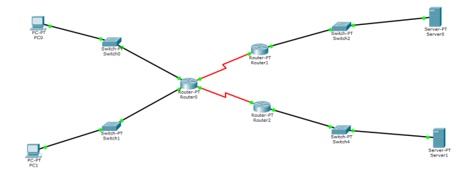**Pract 4**

Gateway = 192.168.11.3

PC0 > Destop > IP Config > IP, SM, DG (ip 192.168.0.1)

PC1>> Same

RO >> Config>>Interface>> Fastethernet 0/0 ip 192.168.0.1

Fastethernet 1/0 ip 192.168.1.1

Serial2/0 ip 192.168.2.1

S3/0 ip 192.168.3.1

Same for R1 and R2

Click on Router0 >> cli >> press ctrl+z >> type show ip routes

**Pract 6**

**Implement a wireless sensor network simulation**

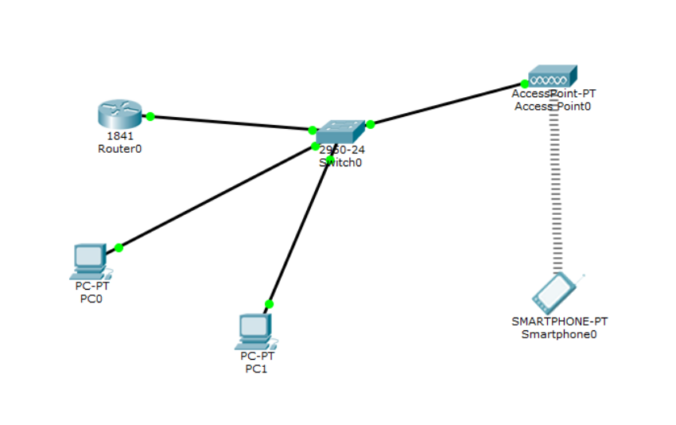

PC0

PC0>>Desktop >> IP Config

Ip add >> 192.168.11.2

Config>>interface>> Fastethernet On

Smartphone

Config>>wireless>>authentication should be disabled

Ipconfig >> static >> ip add 192.168.11.4

Desktop>> Ip config>> Def Gateway 192.168.11.1

Router

Config>> F0/0, F1/1>> ip 192.168.1.1 (on)

Send packet from pc0 to phone

**Pract 7**

Create a mac protocol simulation for wireless sensor network

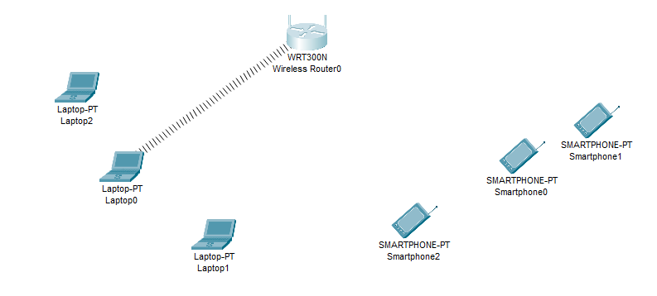

Laptop1

1 Click on laptop 1

2 turn off laptop1, remove the part and put wpc300n/nm-1w

3 click on config>>wireless>> copy mac address

Router

Gui >> wireless >>wireless mac filter >> enable >> enter copied mac address **(00:D0:FF:D8:57:EA in this format**) (permit or prevent depends on the question given)>> scroll down and **save changes**

**Practical 8**

**Create a mobile network using Cell Tower, Central Office Server, Web browser and Web Server. Simulate connection between them.**

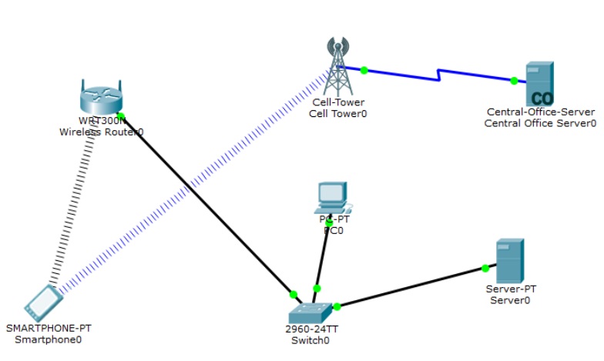

**Smartphone**

Desktop>>ip address static 192.168.11.1>>gateway 192.168.0.1

**PC**

Ip address >> 192.168.0.101 >> default gateway 192.168.0.1

**Server**

Desktop>>ip config>> ip address 192.168.0.102>> gateway 192.168.0.1

Send packet pc to server pt